Baby version pre-lease testing guide:

Choose one that fit your system, this step is important because you will need it to scrape the data from Glassdoor:

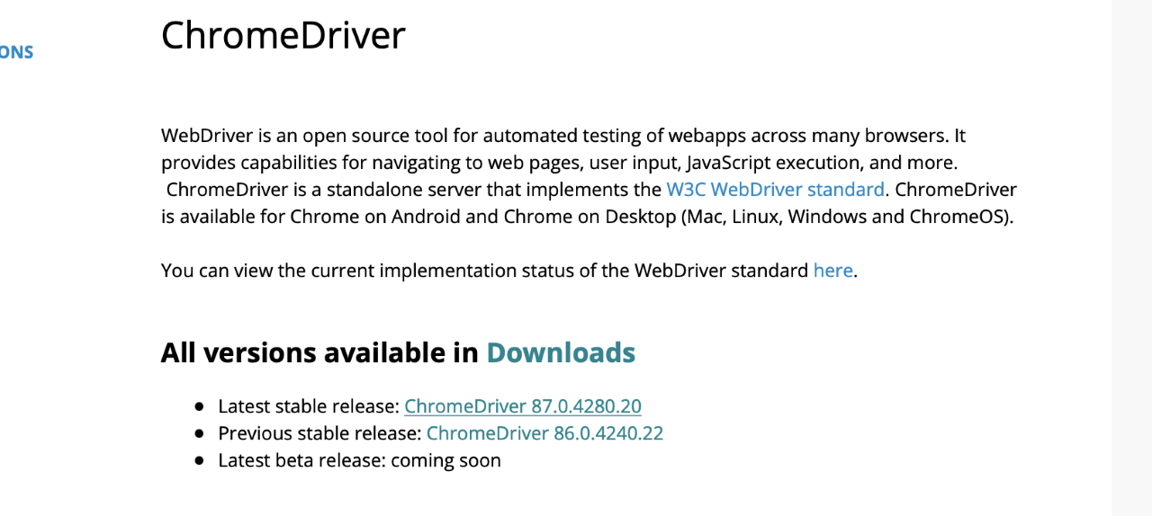

download the release and replace it with the Chromed Driver in the pre-release .zip files, every single one of it,

Website: <https://sites.google.com/a/chromium.org/chromedriver/>

download the release and replace it with the ChromeDriver in our .zip files, every single one of it.

In Anaconda, please set the environment first to bring all the drivers working:

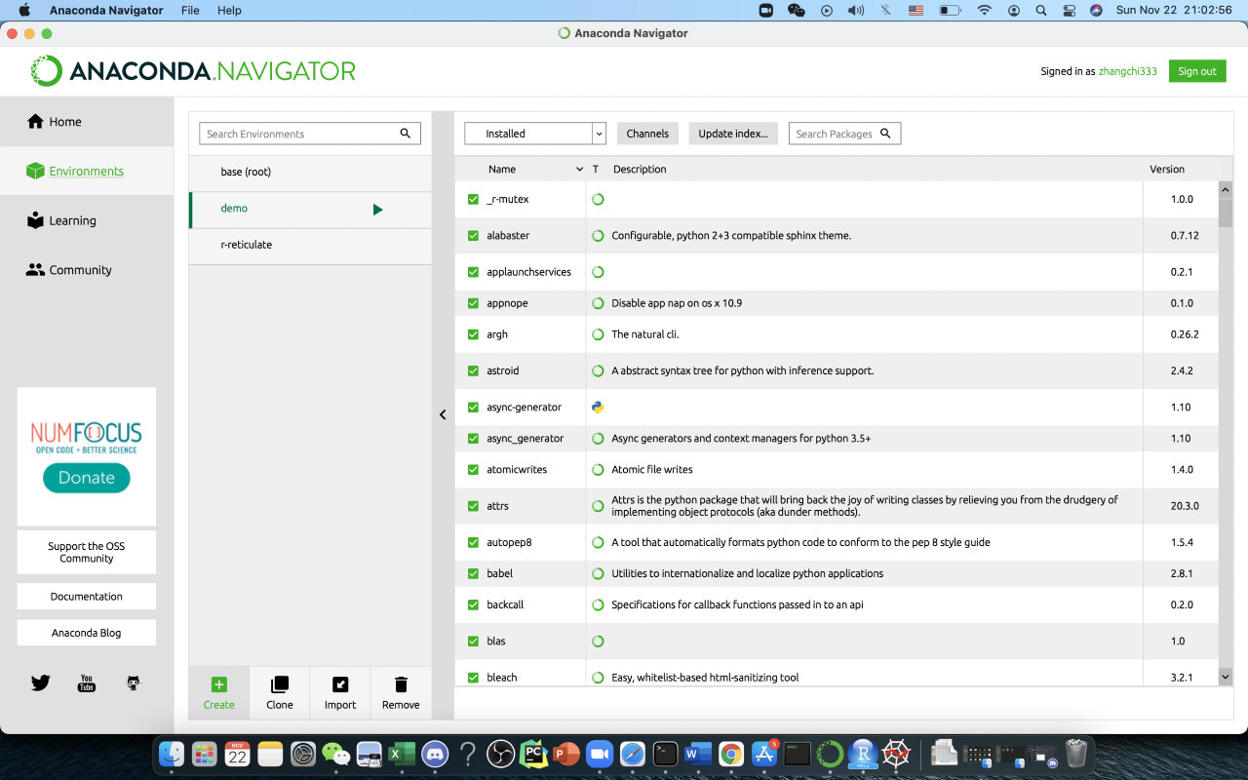

Hit the green "Create" right beside the Clone,

Then,

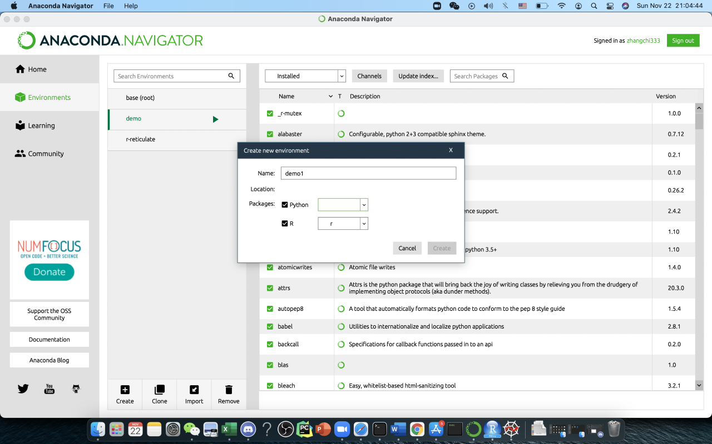

choose R (r) and python (3.0+ I guess, must be python 3) version, give the new enviroment a name and hit create.

When it is done, open the Home on the left:

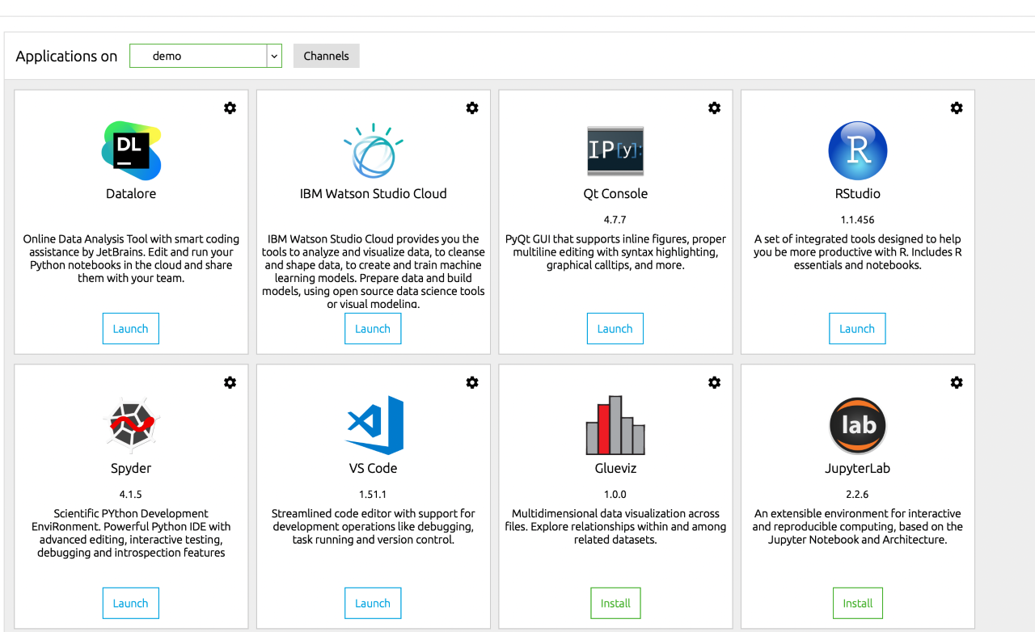

Then install the Rstudio, Jupyter notebook and Spyder under the environment you create just then (in this case mine is "demo")

Before we begin scrapping, we need to add python dependents into the environment like this:

Go back to anaconda, see the pic below, search "selenium" (also “numpy” and “pandas” and install it, then reopen the spyder and refresh)

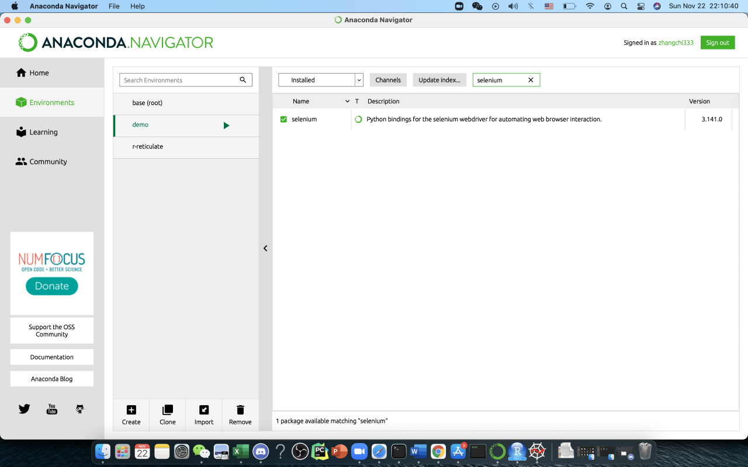

Test Procedure of Panel 1

First, make sure you all follow and set up the anaconda environment properly.

(you can skip the jupyter notebook testing because we have already bringing all the scraping code to spyder and made it work, they are basically the same)

Then, open the spyder in anaconda:

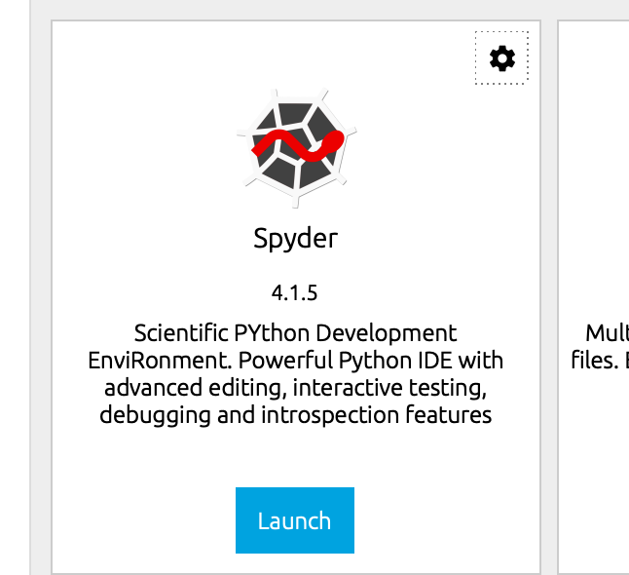

Next, please choose “project -🡪open project” and open the “JS1” folder in the .zip file you download

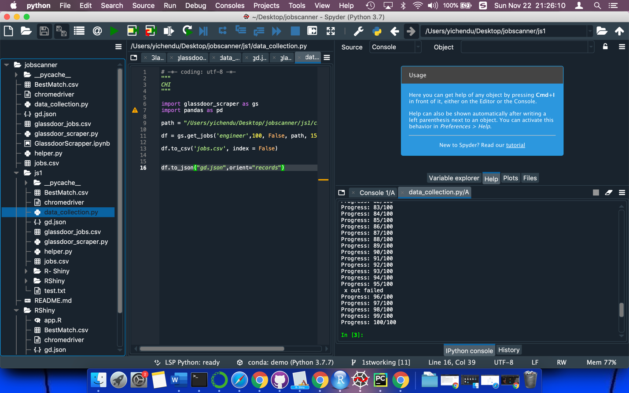

Then you need to replace the selenium webdriver that fit your own PC in the file folder and replace the local path in your own computer in “data_collection.py”, I use my friend Yichen’s computer to show you this demo since this laptop has no important data to lose lol.

In this case my local path of the selenium driver is: /Users/yichendu/Desktop/jobscanner/js1/chromedriver,

Also, you can change the job you’d like to scrap, just change the “engineer” right below it into anything you’d like to do a job matching.

After that, right click the data-collection to make it run, if selenium web driver path is not correct you will get the red warning down below:

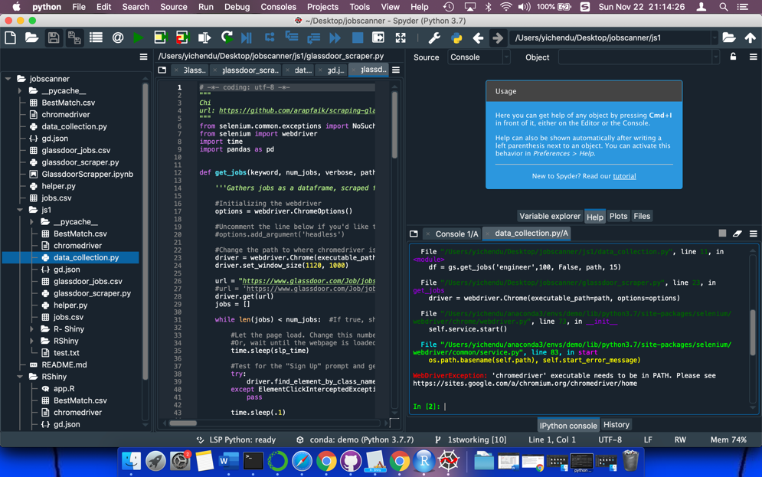

If nothing happens, we are good to go!

The web scrapping is working as below, it will take a few seconds to get started, it will collect 100 job lists. In this case, consider you will wait a long time to get it done I suggest you change the

﻿df = gs.get_jobs('engineer',100, False, path, 15)

The second number “100” into the actual job lists you want to web scrapped, e.g.; 10, to shorten the test waiting time.

:

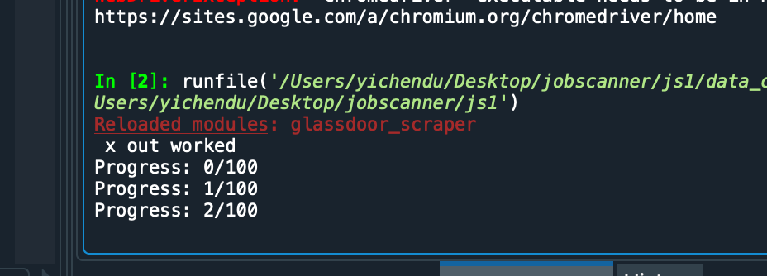

Once the scrapping is working you will see a google chrome pops out and a blue rectangle moving to scrap the info you need. Please wait till all the job lists scrapped and done.

Then we can move to the final test-----web app panel then.

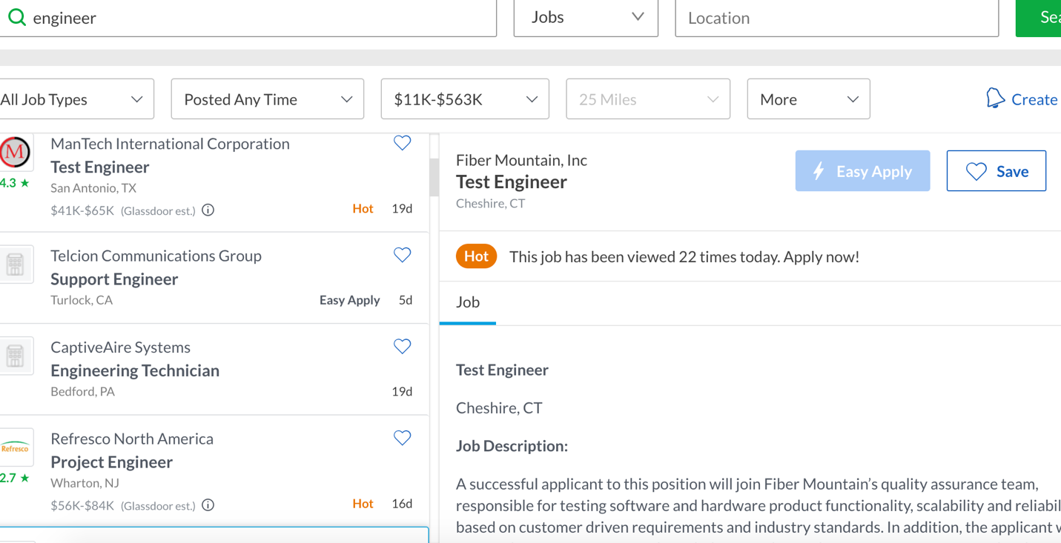

Test part 2-----local testing the applicant panel:

In Anaconda, please set the environment first to bring all the drivers working:

1. Once you have done with the web scrapping (meaning you have updated the job lists we are going to do the matching),

copy the “gd.json” that inside “js1” file that just generated, paste into the file folder “Rshiny” inside “JS1”, if “Rshiny” already have one “gd.json”, choose replace it.

1. open the “Rstudio” under the same environment of anaconda:

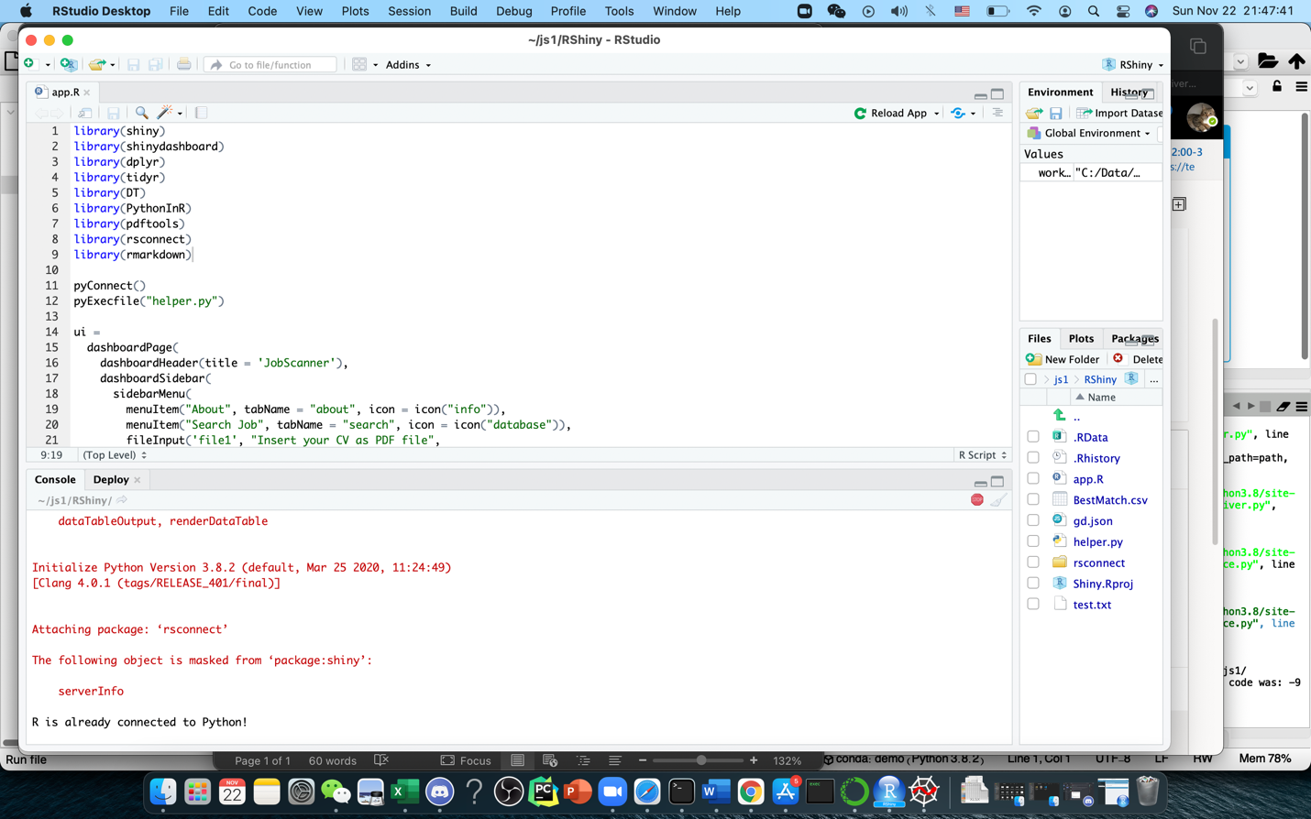

1. choose “open project” on the upper right-hand side:

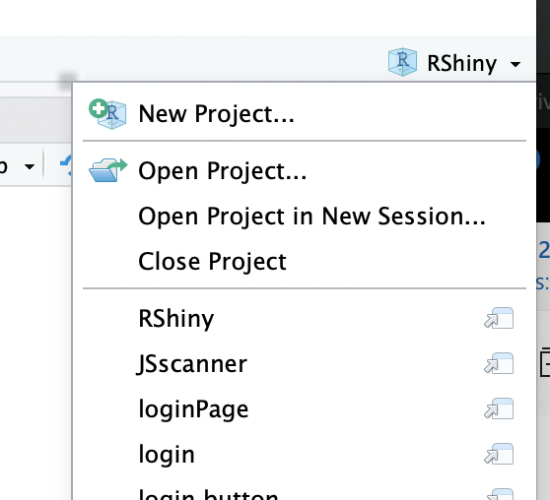

Then open the “Rshiny” project inside “JS1”, (“JS1” is inside the whole file folder you have download it just then.)

It will look like this:

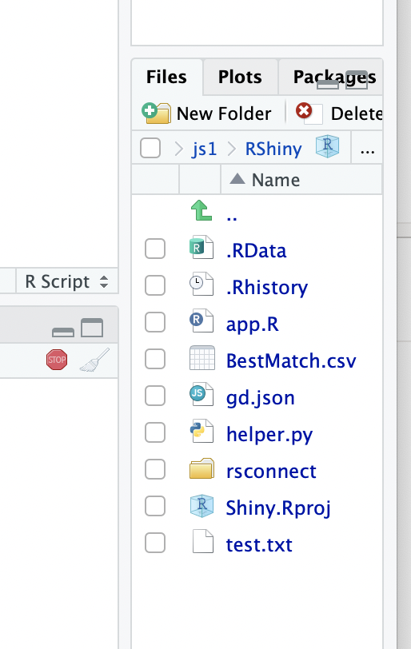

Click the “app.R”, the left hand side will look like this:

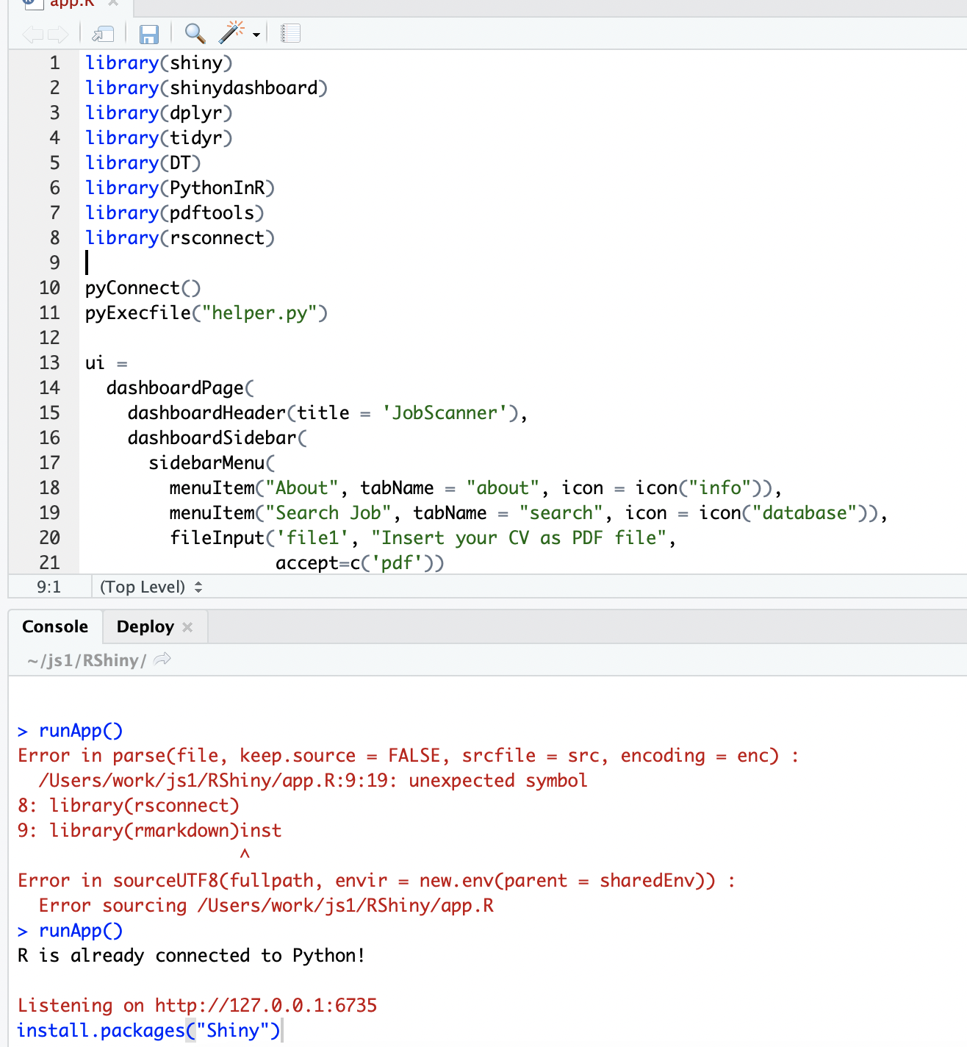

In the console, install all the CRAN library using install.packages(“….”)

Here the packages is in R code: shiny, shinydashboard, dplyr, tidyr, DT, PythonInR, pdftools, rsconnect, replace “….” with each of it in install.packages(“….”), then hit enter/return, it will normally install automatically,

This is what the correct install message like:

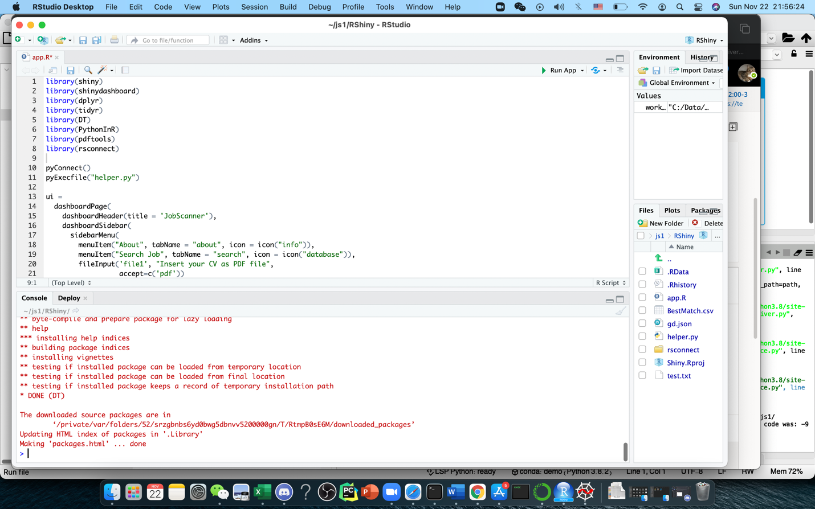

Once all the library is done installing, move the mouse to app.R and it will show Run App with the green arrow in front of it, hit it:

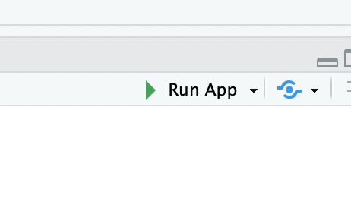

Then Rstudio will show a pop out window like this:

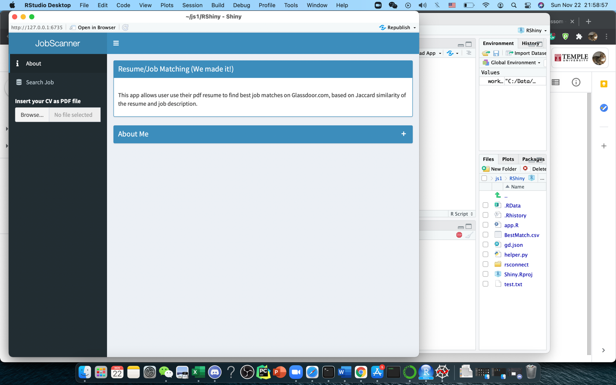

This is the beginning of our matching test:

Hit Browse and upload a resume, I use our dear TA Ian’s resume (pdf/docx/txt form) in this case:

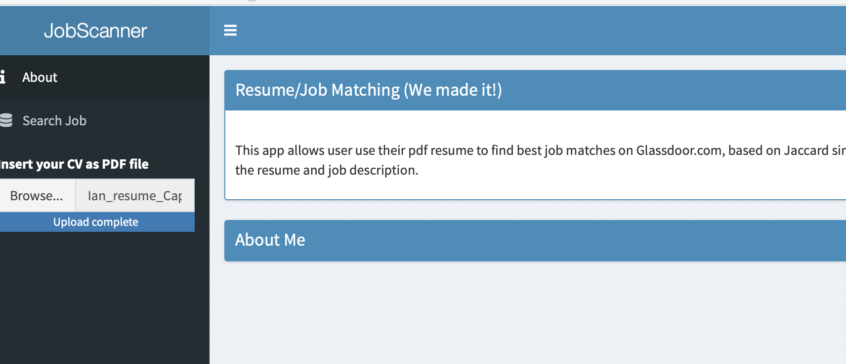

Then hit search job:

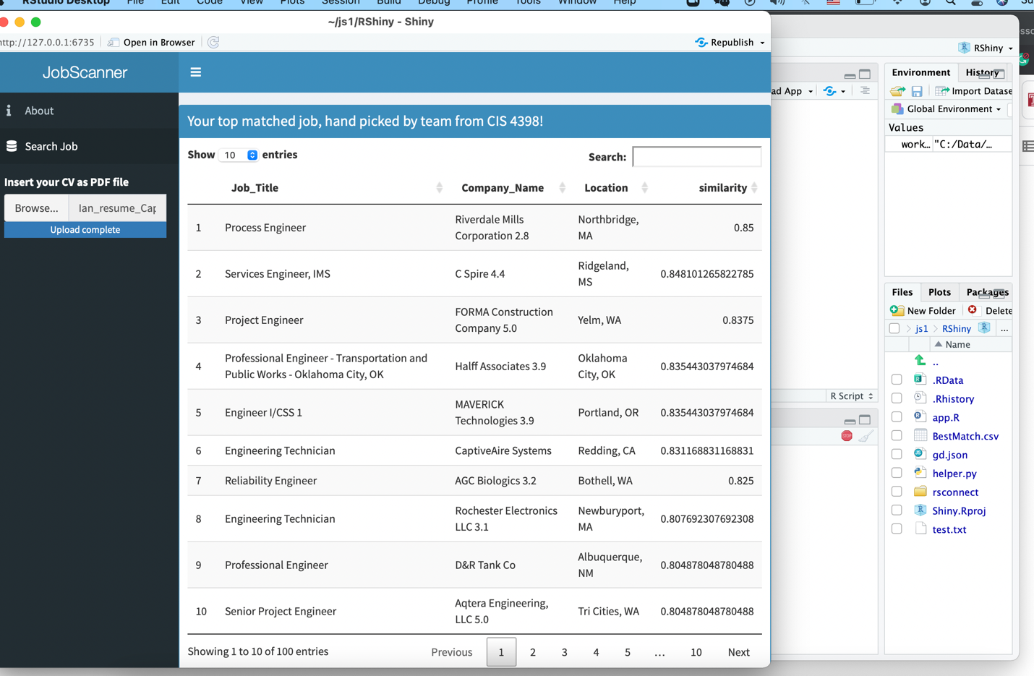

It will pop out job match that we just scraped and using Jaccard similarity to give Ian a job match!

Look at the right-hand side similarity, the closer to 1 the more likely Ian could get the job by applying it (we compare the similarity with the job description with his resume, the more keywords he had in resume, the more he fits the job). This is just our baby version, we will bring the updated one later this week.

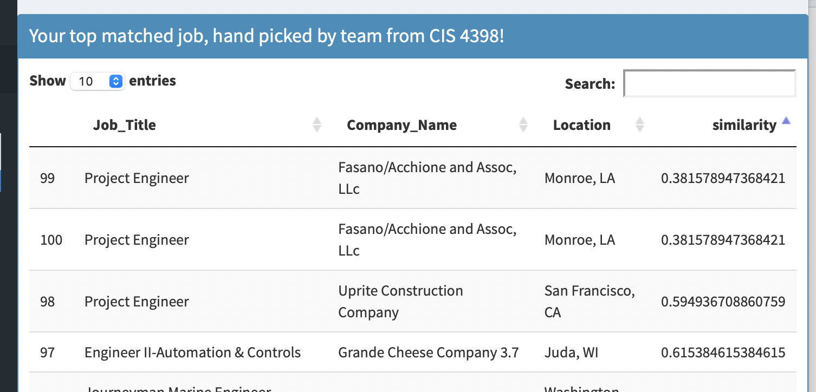

Click the similarity arrow, the least fit job is there instead:

Or we can manually screen the job list by type in job key word in “search” right beside “location”:

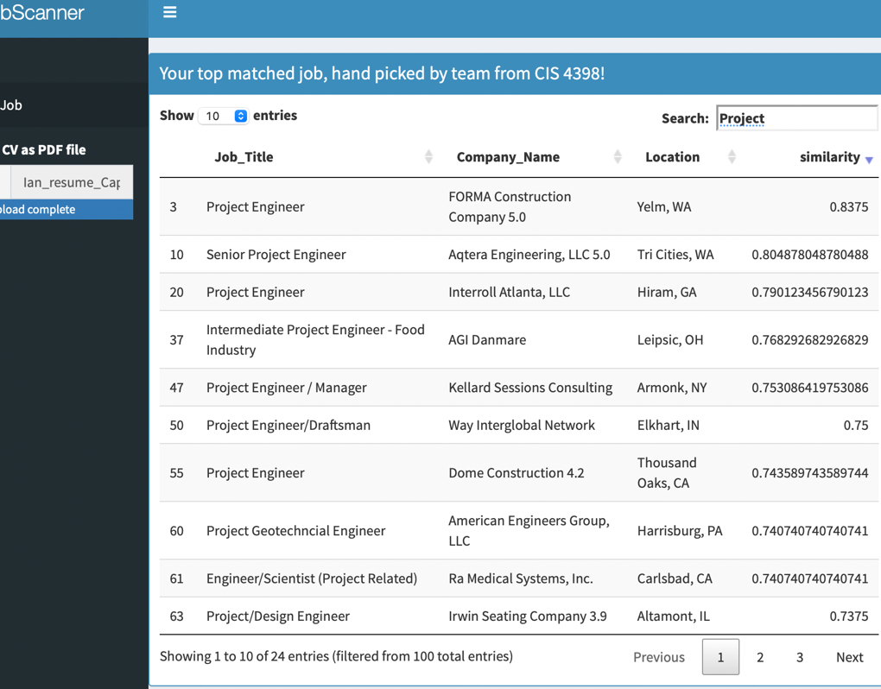

Then it will only match the job fits in describe with title or job description keywords in “project” only.

Our known bugs are the publishing, still the publish cannot be done now in all 5 panels and we are working to fix it:

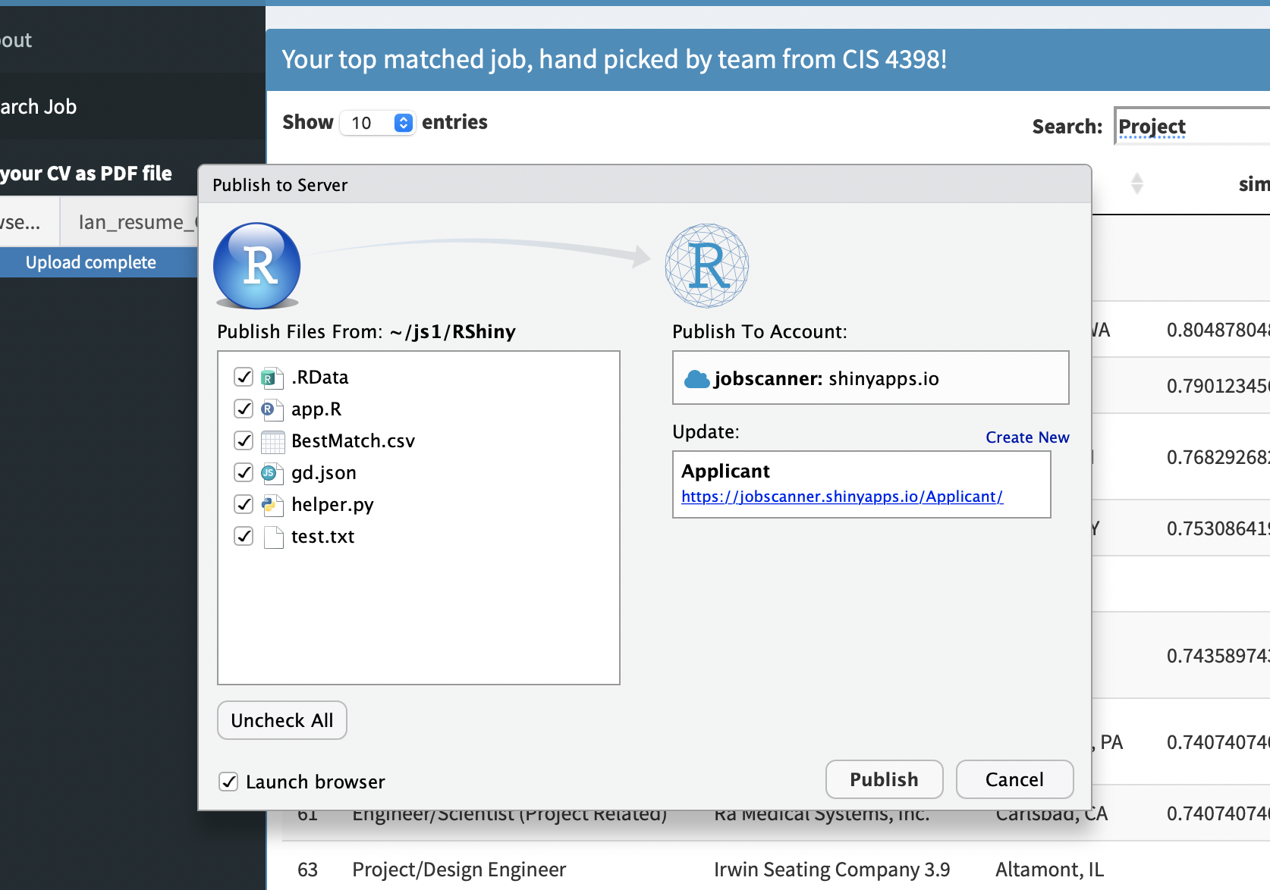

Our error page and known bugs:

(right now, we are working to fix it)

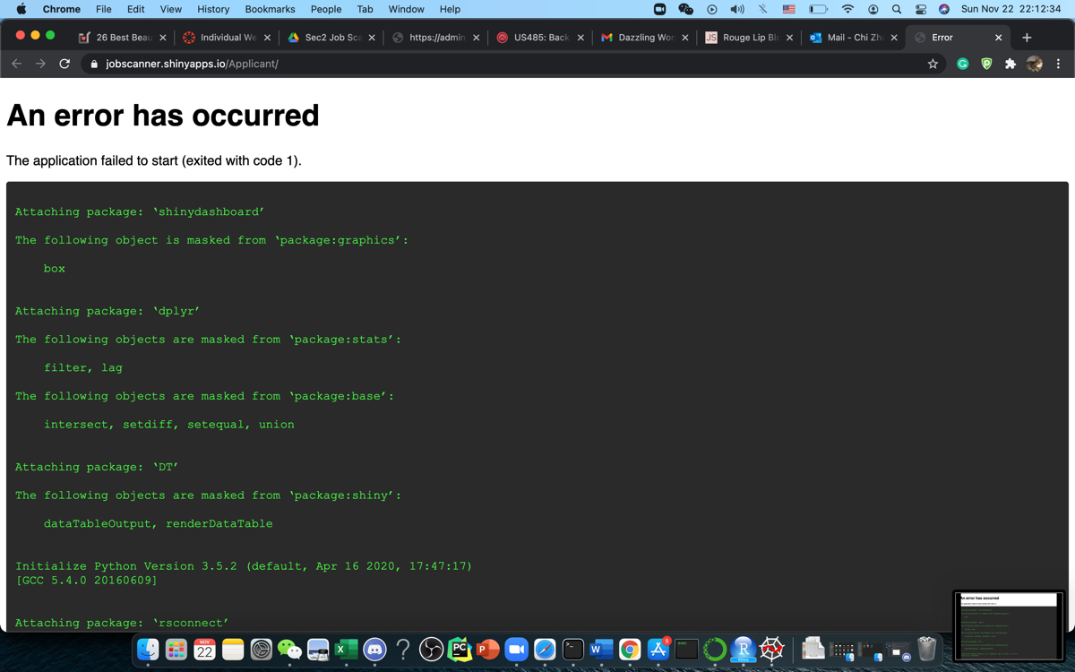

Besides publish issue, some different settings of computer could not run our front-end properly due to the R setting.